Section 1: Task 1 - Flutter & Dart Setup
Flutter Doctor Check
I used flutter doctor to check my Flutter development setup.
My system is using:
Flutter 3.47.1
Dart 3.13.1
Windows 11
Flutter found Chrome successfully three devices connected and network resources.. The check showed that the Android SDK is not set up and Visual Studio is not installed for Windows desktop work. Flutter also sent a Dart PATH warning because a different Dart SDK is earlier, in the system PATH.
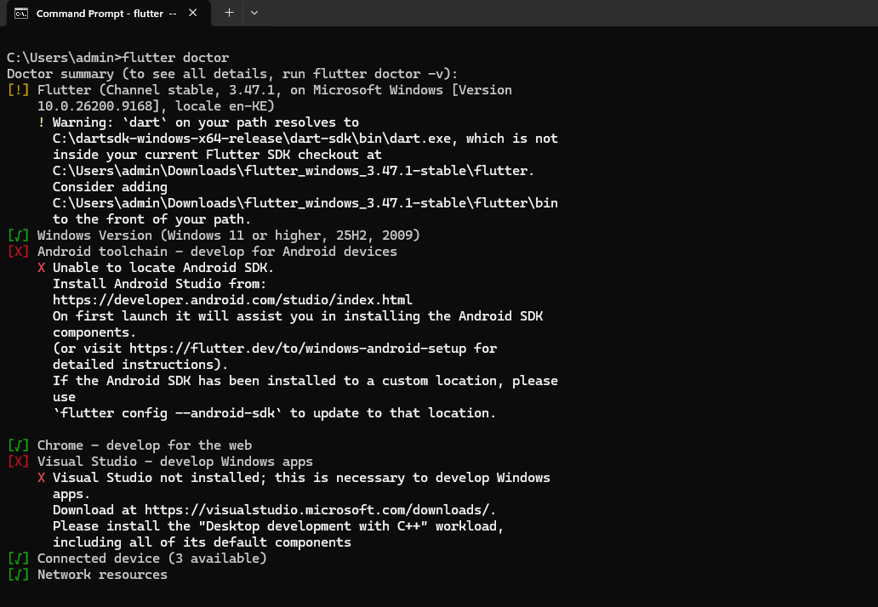
Flutter Devices
I started a Flutter project called my_first_app. Then I used the command flutter devices to see what devices I can use to run my app.
The command found three devices that I can use:
* Windows desktop. It is called windows-x64
* Chrome web. It is called web-javascript
* Edge web. It is called web-javascript
I do not see any Android devices or emulators on the list because I did not set up the Android SDK on my computer. I need to set up the Android SDK to use Android devices with my Flutter application my_first_app.
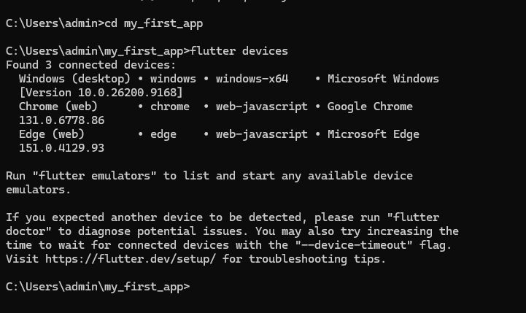
Q.What is the difference between Hot Reload and Hot Restart in Flutter. A developer needs to know when to use each of these features.
To understand this let us look at Hot Reload and Hot Restart
Hot Reload is a feature that updates the Flutter application with code changes without stopping the application. This means the current state of the application is saved. A developer should use Hot Reload when they make changes to the user interface or the code and they want to see the results right away without losing the current state of the Flutter application.
On the hand Hot Restart is a feature that completely stops the Flutter application and starts it again from the beginning. This means the current state of the Flutter application is lost. A developer should use Hot Restart when they make changes that require the Flutter application to start or when they want to reset the current state of the Flutter application.
Here are the main points to remember about Hot Reload and Hot Restart:
* Hot Reload is used to make changes to the Flutter application and see the results quickly without losing the current state of the Flutter application.
* Hot Restart is used to restart the Flutter application and lose the state of the Flutter application.
Simple Difference
* Hot Reload → Makes changes, to the code quickly. Keeps the current state of the Flutter application
* Hot Restart → Restarts the Flutter application and loses the current state of the Flutter application

Section 2: Task 2 - MySQL Database Management
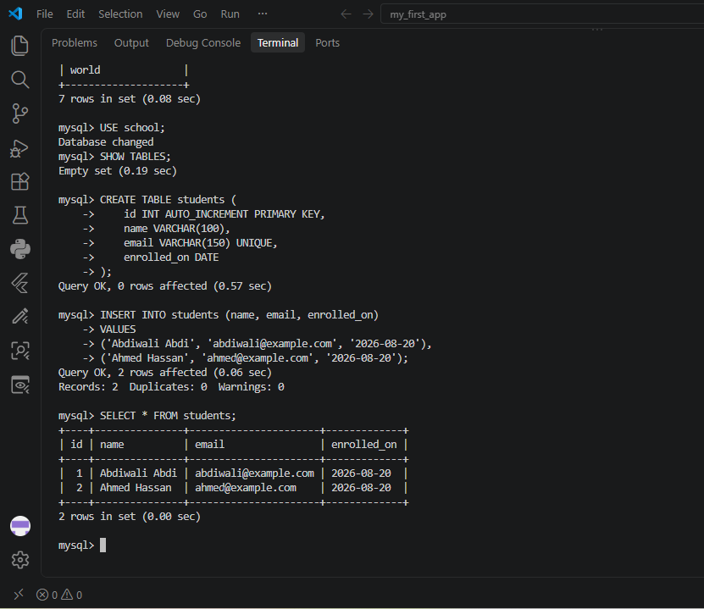

mysql> CREATE DATABASE school;
Query OK, 1 row affected (0.15 sec)

mysql> SHOW DATABASE
-> SHOW DATABASE;
ERROR 1064 (42000): You have an error in your SQL syntax; check the manual that corresponds to your MySQL server version for the right syntax to use near 'DATABASE
SHOW DATABASE' at line 1
mysql> SHOW DATABASE;
ERROR 1064 (42000): You have an error in your SQL syntax; check the manual that corresponds to your MySQL server version for the right syntax to use near 'DATABASE' at line 1
mysql> SHOW DATABASE;
ERROR 1064 (42000): You have an error in your SQL syntax; check the manual that corresponds to your MySQL server version for the right syntax to use near 'DATABASE' at line 1
mysql> SHOW DATABASES;
+--------------------+
| Database |
+--------------------+
| information_schema |
| mysql |
| performance_schema |
| sakila |
| school |
| sys |
| world |
+--------------------+
7 rows in set (0.08 sec)

mysql> USE school;
Database changed
mysql> SHOW TABLES;
Empty set (0.19 sec)

mysql> CREATE TABLE students (
-> id INT AUTO_INCREMENT PRIMARY KEY,
-> name VARCHAR(100),
-> email VARCHAR(150) UNIQUE,
-> enrolled_on DATE
-> );
Query OK, 0 rows affected (0.57 sec)

mysql> INSERT INTO students (name, email, enrolled_on)
-> VALUES
-> ('Abdiwali Abdi', 'abdiwali@example.com', '2026-08-20'),
-> ('Ahmed Hassan', 'ahmed@example.com', '2026-08-20');
Query OK, 2 rows affected (0.06 sec)
Records: 2 Duplicates: 0 Warnings: 0

mysql> SELECT * FROM students;
+----+---------------+----------------------+-------------+
| id | name | email | enrolled_on |
+----+---------------+----------------------+-------------+
| 1 | Abdiwali Abdi | abdiwali@example.com | 2026-08-20 |
| 2 | Ahmed Hassan | ahmed@example.com | 2026-08-20 |
+----+---------------+----------------------+-------------+
2 rows in set (0.00 sec)

mysql> CREATE USER 'school_app'@'localhost' IDENTIFIED BY 'schoolApp@2026!';
Query OK, 0 rows affected (0.11 sec)

mysql> GRANT SELECT, INSERT, UPDATE, DELETE
-> ON school.*
-> TO 'school_app'@'localist';
ERROR 1410 (42000): You are not allowed to create a user with GRANT
mysql> GRANT SELECT, INSERT, UPDATE, DELETE
-> ON school.*
-> TO 'school_app'@'localhost';
Query OK, 0 rows affected (0.06 sec)

mysql> SHOW GRANTS FOR 'school_app'@'localhost';
+--------------------------------------------------------------------------------+
| Grants for school_app@localhost |
+--------------------------------------------------------------------------------+
| GRANT USAGE ON *.* TO `school_app`@`localhost` |
| GRANT SELECT, INSERT, UPDATE, DELETE ON `school`.* TO `school_app`@`localhost` |
+--------------------------------------------------------------------------------+
2 rows in set (0.00 sec)

mysql>

Security reflection
Using the root MySQL account for an application connection is not a good idea because root has a lot of power over the database server. If an application is hacked while using the root account someone could change, delete or see databases and important information. Using root also goes against the idea of giving the minimum access needed because the application usually doesn't need full control.
A better way is to make a database user that only has the access the application needs. For this job the school_app user was. Given the ability to select, insert, update and delete data only on the school database.
SQL commands used:
```sql
CREATE USER 'school_app'@'localhost' IDENTIFIED BY 'SchoolApp@2026!';
GRANT SELECT, INSERT, UPDATE, DELETE
ON school.*
TO 'school_app'@'localhost';
SHOW GRANTS FOR 'school_app'@'localhost';
```
The SHOW GRANTS command was used to check that the user can only do the school database tasks that are needed and not have control, over the database.

Section 3: Task 3 - Python Virtual Environment

PS C:\Users\admin> [Environment]::GetFolderPath("Desktop")
C:\Users\admin\OneDrive\Desktop
PS C:\Users\admin> cd "C:\Users\admin\OneDrive\Desktop"
PS C:\Users\admin\OneDrive\Desktop> mkdir python_setup_lab

Directory: C:\Users\admin\OneDrive\Desktop

Mode LastWriteTime Length Name
---- ------------- ------ ----
d----- 8/21/2026 12:12 AM python_setup_lab

PS C:\Users\admin\OneDrive\Desktop> cd .\python_setup_lab\
PS C:\Users\admin\OneDrive\Desktop\python_setup_lab> cd "C:\Users\admin\OneDrive\Desktop"
PS C:\Users\admin\OneDrive\Desktop> cd .\python_setup_lab\
PS C:\Users\admin\OneDrive\Desktop\python_setup_lab> python -m venv venv
PS C:\Users\admin\OneDrive\Desktop\python_setup_lab> dir

Directory: C:\Users\admin\OneDrive\Desktop\python_setup_lab

Mode LastWriteTime Length Name
---- ------------- ------ ----
d----- 8/21/2026 12:14 AM venv

PS C:\Users\admin\OneDrive\Desktop\python_setup_lab> .\venv\scripts\Activate.ps1
.\venv\scripts\Activate.ps1 : File
C:\Users\admin\OneDrive\Desktop\python_setup_lab\venv\scripts\Activate.ps1
cannot be loaded because running scripts is disabled on this system. For
more information, see about_Execution_Policies at
https:/go.microsoft.com/fwlink/?LinkID=135170.
At line:1 char:1
+ .\venv\scripts\Activate.ps1
+ ~~~~~~~~~~~~~~~~~~~~~~~~~~~
+ CategoryInfo : SecurityError: (:) [], PSSecurityException
+ FullyQualifiedErrorId : UnauthorizedAccess
PS C:\Users\admin\OneDrive\Desktop\python_setup_lab> .\venv\Scripts\Activate.ps1
.\venv\Scripts\Activate.ps1 : File
C:\Users\admin\OneDrive\Desktop\python_setup_lab\venv\Scripts\Activate.ps1
cannot be loaded because running scripts is disabled on this system. For
more information, see about_Execution_Policies at
https:/go.microsoft.com/fwlink/?LinkID=135170.
At line:1 char:1
+ .\venv\Scripts\Activate.ps1
+ ~~~~~~~~~~~~~~~~~~~~~~~~~~~
+ CategoryInfo : SecurityError: (:) [], PSSecurityException
+ FullyQualifiedErrorId : UnauthorizedAccess
PS C:\Users\admin\OneDrive\Desktop\python_setup_lab> Set-ExecutionPolicy -Scope Process -ExecutionPolicy Bypass
PS C:\Users\admin\OneDrive\Desktop\python_setup_lab> .\venv\Scripts\Activate.ps1
(venv) PS C:\Users\admin\OneDrive\Desktop\python_setup_lab> python -m pip install requests
Collecting requests
Downloading requests-2.34.2-py3-none-any.whl.metadata (4.8 kB)
Collecting charset_normalizer<4,>=2 (from requests)
Downloading charset_normalizer-3.5.1-cp313-cp313-win_amd64.whl.metadata (46 kB)
Collecting idna<4,>=2.5 (from requests)
Downloading idna-3.19-py3-none-any.whl.metadata (9.2 kB)
Collecting urllib3<3,>=1.26 (from requests)
Downloading urllib3-2.7.0-py3-none-any.whl.metadata (6.9 kB)
Collecting certifi>=2023.5.7 (from requests)
Downloading certifi-2026.7.22-py3-none-any.whl.metadata (2.5 kB)
Downloading requests-2.34.2-py3-none-any.whl (73 kB)
Downloading charset_normalizer-3.5.1-cp313-cp313-win_amd64.whl (199 kB)
Downloading idna-3.19-py3-none-any.whl (68 kB)
Downloading urllib3-2.7.0-py3-none-any.whl (131 kB)
Downloading certifi-2026.7.22-py3-none-any.whl (136 kB)
Installing collected packages: urllib3, idna, charset_normalizer, certifi, requests
Successfully installed certifi-2026.7.22 charset_normalizer-3.5.1 idna-3.19 requests-2.34.2 urllib3-2.7.0
(venv) PS C:\Users\admin\OneDrive\Desktop\python_setup_lab> pip list
Package Version
------------------ ---------
certifi 2026.7.22
charset-normalizer 3.5.1
idna 3.19
pip 26.2.1
requests 2.34.2
urllib3 2.7.0
(venv) PS C:\Users\admin\OneDrive\Desktop\python_setup_lab> pip freeze > requirements.txt
(venv) PS C:\Users\admin\OneDrive\Desktop\python_setup_lab> dir

Directory: C:\Users\admin\OneDrive\Desktop\python_setup_lab

Mode LastWriteTime Length Name
---- ------------- ------ ----
dar--l 8/21/2026 12:15 AM venv
-a---l 8/21/2026 12:22 AM 188 requirements.txt

(venv) PS C:\Users\admin\OneDrive\Desktop\python_setup_lab>

Section 4: Task 4 - VS Code Workspace Configuration

